Traffic Signal Management  
  
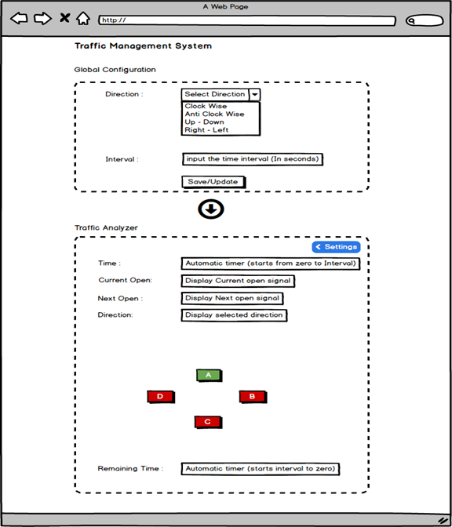

As shown in image, Traffic management practical will consist two pages / wizard as following,

1. Global Configuration
2. Traffic Analyzer

# Global Configuration:

* This wizard consists global configuration that can be save/update.
* By running the application, it should open this form and user can fill all parameters and save it. It should be saved in database, so it should be used when 2nd wizard (Traffic Analyzer) is running.  
  You can create the table at your own for this.
* There are two parameters in this form:
  + Direction: It will be a single select dropdown with following values:   
    - Clockwise  
    - Anti Clock wise  
    - Up & Down  
    - Left & Right  
    User can select any of these options and save it.
  + Interval: It will be a free form textbox which is used to enter time interval in seconds.
* Once user will submit the form with all values, it will be close this form and open a new form.

# Traffic Analyzer:

This screen will be used to monitor the traffic signals and their statuses. It will show that which signal is currently open.

At the top, there are 4 labels displayed which will work following  
  
**Time**: It will be a label which will work real time based on values selected on Global configuration screen for interval. For example, if interval may set to 15 seconds then Time will start from zero to 15. It will be real time and once it may reach to interval then it will start again from zero. 0, 1, 2…14, 15  
  
**Remaining time**: It will be a label and similar to the Time field. It will work reversely. It will start from interval to zero. For example, 15, 14, 13, 12…..2, 1, 0. All other operations will be similar to Time field.  
  
**Current Open**: It will be a label which shows the current signal which is open at the moment.  
  
**Next Open:** It will be a label which shows the next signal which will be going to open after the designated time interval.  
  
**Direction**: It will be label which displayed the direction selected from the global configuration file.  
  
Middle part of the Traffic analyzer screen shows the status of each signal on crossroad.  
A, B, C, D: Signal

**Action:**   
  
- Once the application will run, User will choose the direction, interval and save it. It will take them to the 2nd screen.  
- On the 2nd screen, it will show the direction on the label. When the screen will load at first, timer will start from 0 to interval for Time field and Remaining Time field will be starting from Interval to 0.  
  
For Example: Interval: 10 seconds, Direction: Clock Wise  
  
2nd Screen: Time field will start from 0 to 10 and remaining time field will start from 10 to 0.  
In span of 10 seconds, First A Button will be shows as Green and other buttons (signals) will be Red and Disable.  
  
Once the 10 seconds has been passed, Timer will reset to 0 and start again according to the interval, Signal will be changed as per the direction. All other labels will be changed accordingly like Current Open, Next Open.  
  
If Clock wise direction is selected, it will start from A to B, B to C, C to D, and D to A.  
For Anti clock wise, It will be in A, D, C, B, A  
For Up and Down, It will be A, C, A, C  
For Left and Right, It will be B, D, B, D  
  
As per the time interval and direction, After every time interval passed, Signal will be changed as per direction.  
  
It should work in all directions.  
  
There is an option called settings in 2nd screen, by clicking on it, it should open the global configuration and form can be updated again and 2nd screen will be refreshed and work as per the given parameters.